Chapter 2, Problem 42.

Reduce each of the circuits in Fig. 2.106 to a single resistor at terminals a-b.

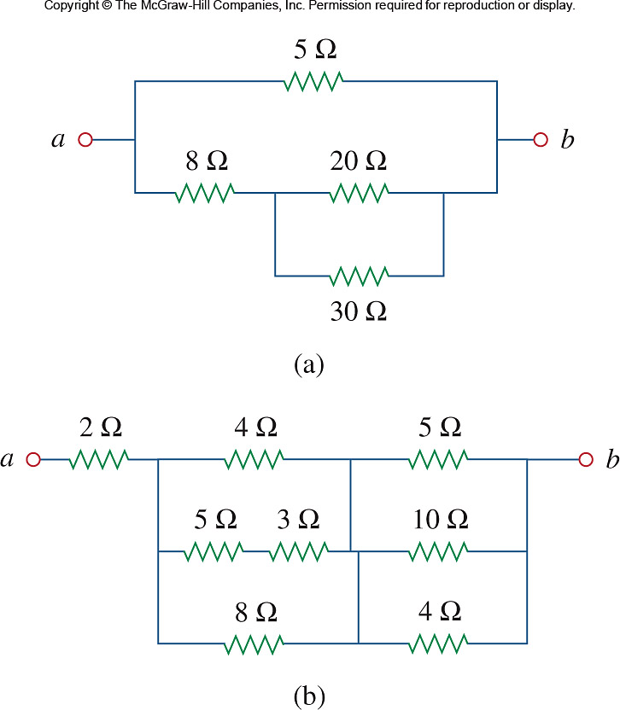

Figure 2.106
For Prob. 2.42.

